CMS Makeup Points after up gradation

1. The old record of term Fall 2022 status done but before up gradation It is in draft state. The details of the department are provided below.

BS Commerce Bachelor business administration Botany Criminology
Social work

similarly in spring 2023 term as well.
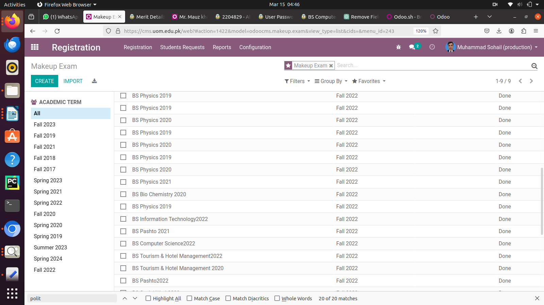

2. Some of the record have missing the status bar like botany Urdu commerce.
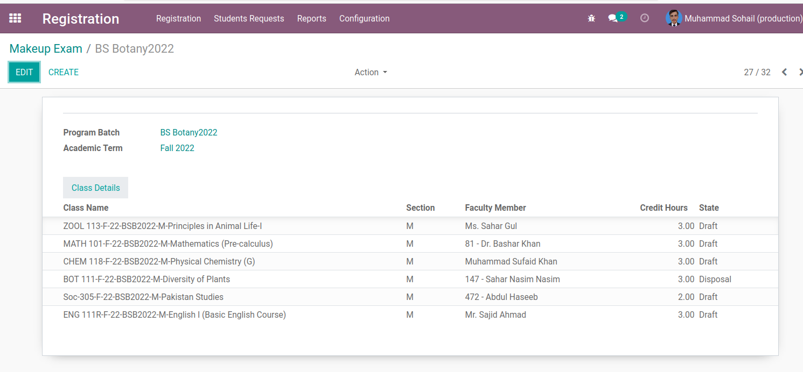

3. The approve and revise button not present for these old record.

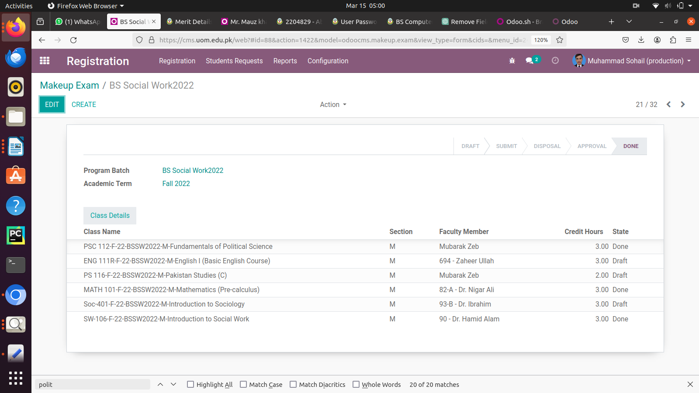
4. Geology record still same we not see changes according to the requirements. We have also tried creating a new record, but the issue persists.

